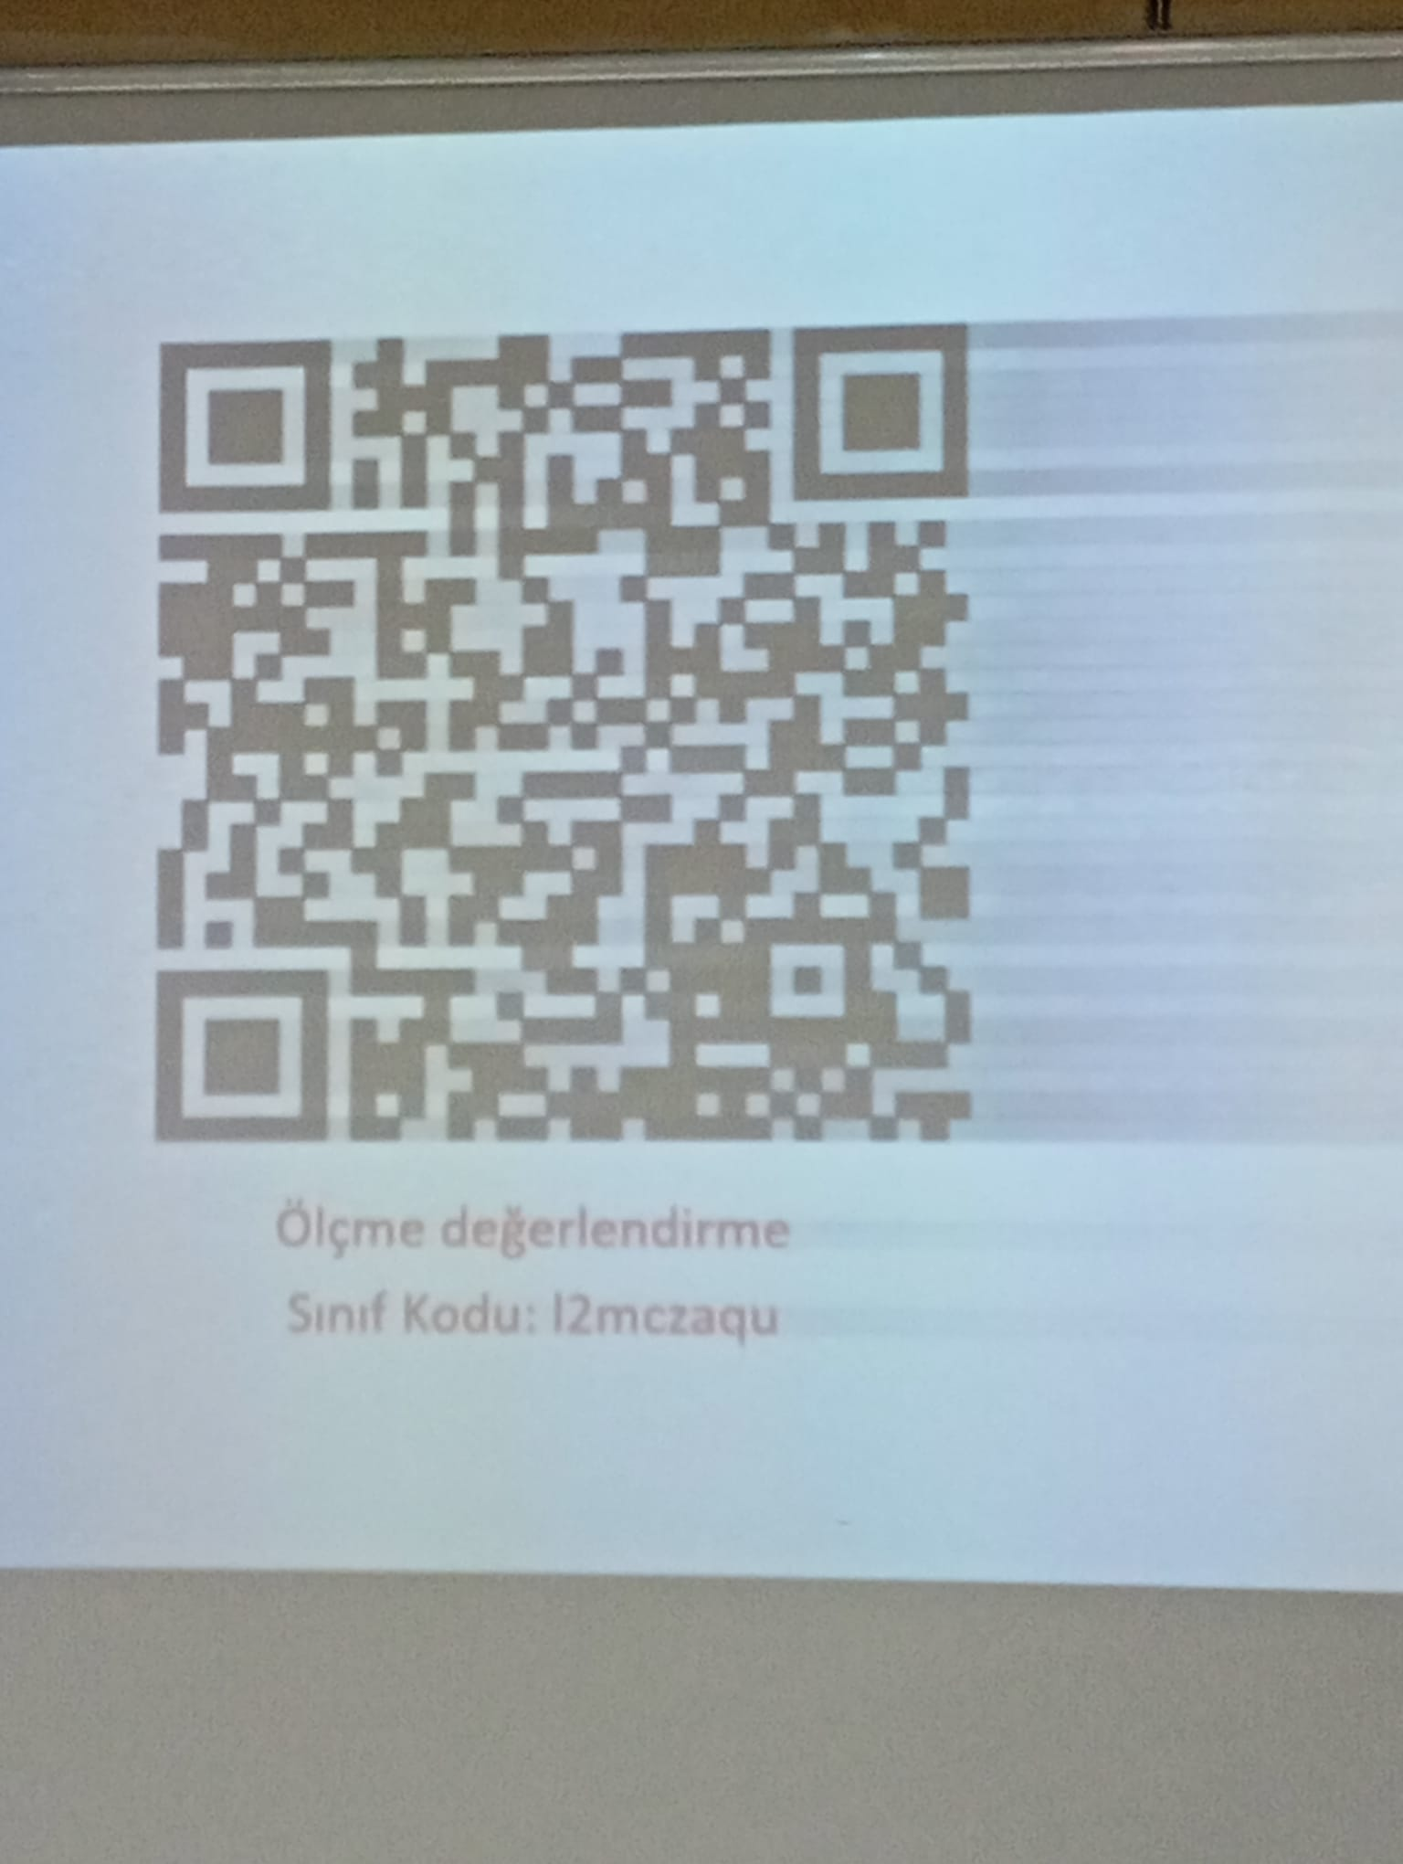
https://classroom.google.com/c/ODExMTc5Mzg3OTg2

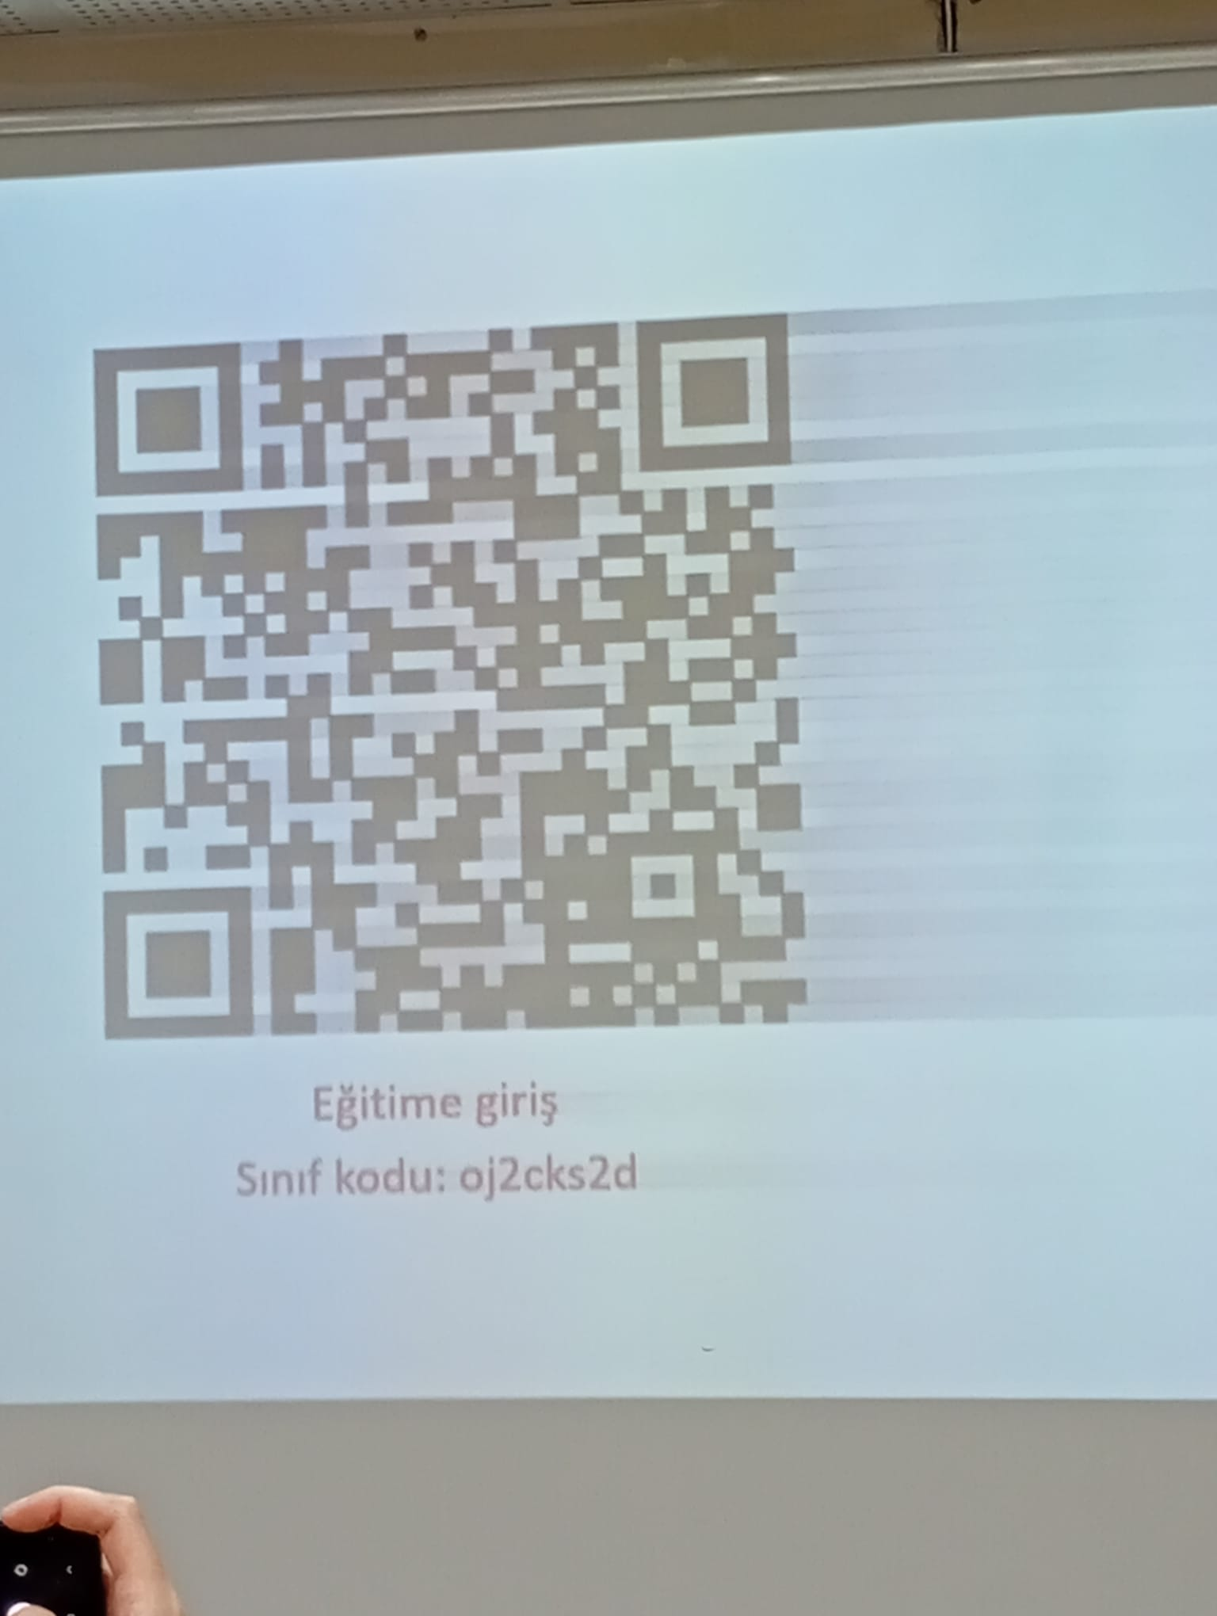
https://classroom.google.com/c/ODExMTgwMjc1MzYy

